General Questions

By Rathod Raja V.

1. What do you understand by System Calls? How System Call Works? How the context switching is related to System call?
Ans:
1. Provide interface between a process and operating system.
2. It is controlled entry point to the kernel, allowing a process to request that the kernel perform some action on the process behalf.
3. The kernel makes a range of services accessible to programs via the system call application programming interface (API).
4. These service includes, example creating a new process, performing I/O , and creating pipe for interprocess communication.
5. A system call changes the processor state from user mode to kernel mode, so
that the CPU can access protected kernel memory.
6. The set of system calls is fixed. Each system call is identified by a unique number.
7. Each system call may have a set of arguments that specify information to be
transferred from user space to kernel space and vice versa.
8.Steps in executing system call:
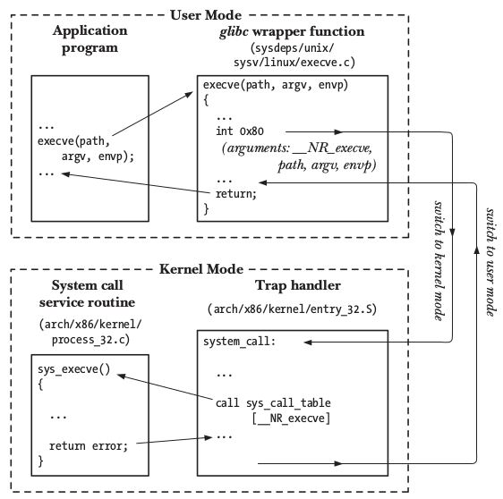

9.When making a system call in Linux, a context switch is done from user-space to kernel space
10. Each process has an associated kernel mode stack, that is used by the system call. Before the system call is executed, the CPU registers of the process are stored on its user-mode stack, this stack is different from the kernel mode stack, and is the one which the process uses for user-space executions.
11. When a process is in kernel mode (or user mode), calling functions of the same mode will not require a context switch.

2. How to add new system call into the Kernel? What are the various steps involved?
3. Explain Linux Booting Process? Why do you need X-Loader?
Ans:
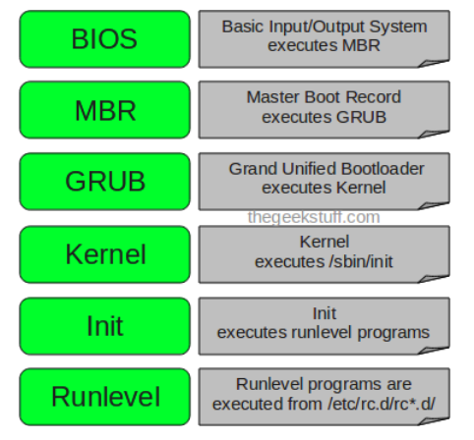

Press the power button on your system, and after few moments you see the Linux login prompt.
Following are the 6 high level stage of typical linux boot process.

1. BIOS

4. What is difference between GPOS (General Purpose Operating System) and Special
Purpose Operating System such as RTOS?
5. How crash is different from panic?
6. How user space is different from kernel space?
7. What are the main modules to implement OS Kernel Functionalities?
8. What are the different types of Kernels?
9. How Kernel is different from OS?
10. How to allocate memory from Kernel Space?
11. Explain about Linux Boot Loaders viz., LILO, GRUB
12. Check with compgen –c command.

